Tarun Kumar, Naveed Ehsan, Fathiat Ayodele, Mehmet Sevik, Tahmeed Chowdhury, Sogo Oyewo, Abdullah Farah

Team 12 Project Binder
INFOPHARMA ORDERING SYSTEM (IPOS - PU)

Prelude:
- Created a WhatsApp group chat to discuss plans, meetings and ideas.
- Discussed a suitable time and date to meet before our allocated interview session with the CEO of InfoPharma
- Planned to meet outside C101 foyer to discuss roles, responsibilities and come up with a draft of questions to clarify any vague criteria of the project brief

First Meeting: January 30th, 10:15am – 11:00am
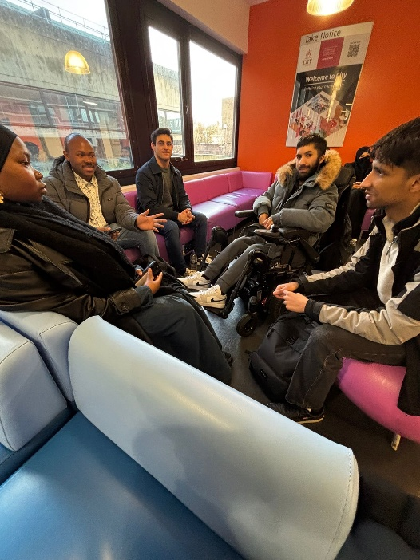
- We all got together before our interview, introduced each other and discussed our section of the Project Brief (Team C IPOS – PU) as well as distributing the roles and future meetups.

Meeting Results:
Following the meeting, everyone’s roles are established:
- Tarun Kumar: Project Manager / Programmer
- Naveed Ehsan: Deputy Project Manager / Lead Programmer
- Fathiat Ayodele: Designer / Systems Analyst
- Mehmet Sevik: Designer / Tester
- Tahmeed Chowdhury: Designer / Tester
- Sogo Oyewo: System Analyst / Programmer
- Abdullah Farah: System Analyst / Programmer

Interview with Mr Lancaster (CEO of InfoPharma)
Our draft of questions:
- How should the system behave if the stock runs out during online purchase?
Don’t offer products that are out of stock, additionally only one customer can buy things at a time (don’t need to worry about race conditions).
- Are there any non-functional requirements (performance, usability) you would like us to prioritise?
There will be marks for how good and consistent user interface is. No specification of non-functional requirements.
- What are the top 5 must-have features for the first prototype?
Being able to do promotional campaigns and discounts depending on popularity of items in campaigns, how likely member of public is likely to purchase the product, reports on counters, allowing people to purchase via the system, in sync with merchants.
- Should the IPOS-PU serve one merchant or multiple merchants?
Singular merchant. Inventory is coming from merchant.
- Since successful commercial customer applicants are given access to IPOS SA, are they also treated as merchants and therefore bounded by the 15 and 30-minutes late payment rules?
They are treated as merchants, involvement with PU is over.
- How should we use the ratio between the items actually ordered and items added to basket but not ordered to decide on promotional campaign (e.g if it is above/below a certain conversion rate)?
Even though conversion rate isn’t necessary to decide items in promotional campaigns it can be a good idea to have it implemented for additional marks and complexity. For example, if a product is not popular is not popular (has a low conversion rate) you can have it on promotion to boost its numbers.
- Does PU buy from the stocks of CA and CA has the same stocks from SA?
There is overlap, PU has exact stock of CA with CA having additional products including beauty products (or whatever other products) so not just the products of SA (InfoPharma). So the public/customers can buy from the CA stock which includes all SA (pharmaceutical products as well as additional merchant products from CA).

Discussing further tasks to be completed over the weekend on WhatsApp
- Come up with a team name and logo
- Create a public GitHub repo for easy collaboration on development
Centralised GitHub repository link: https://github.com/NinetyNineMonths/Team12-IPOS

Team Name
We came up with a team name that incorporates our team number and our main objective in providing a high-quality service for InfoPharma:

T12 Solutions

Logo


Our logo choices between the following (generated with AI)

Second Weekend: Task Designations
We decided to treat our collaborative GitHub environment as not exclusive to programming but also to share our important files, drafts and diagrams.
Project Manager Tarun designating tasks for the key roles of our group:

System Analysts
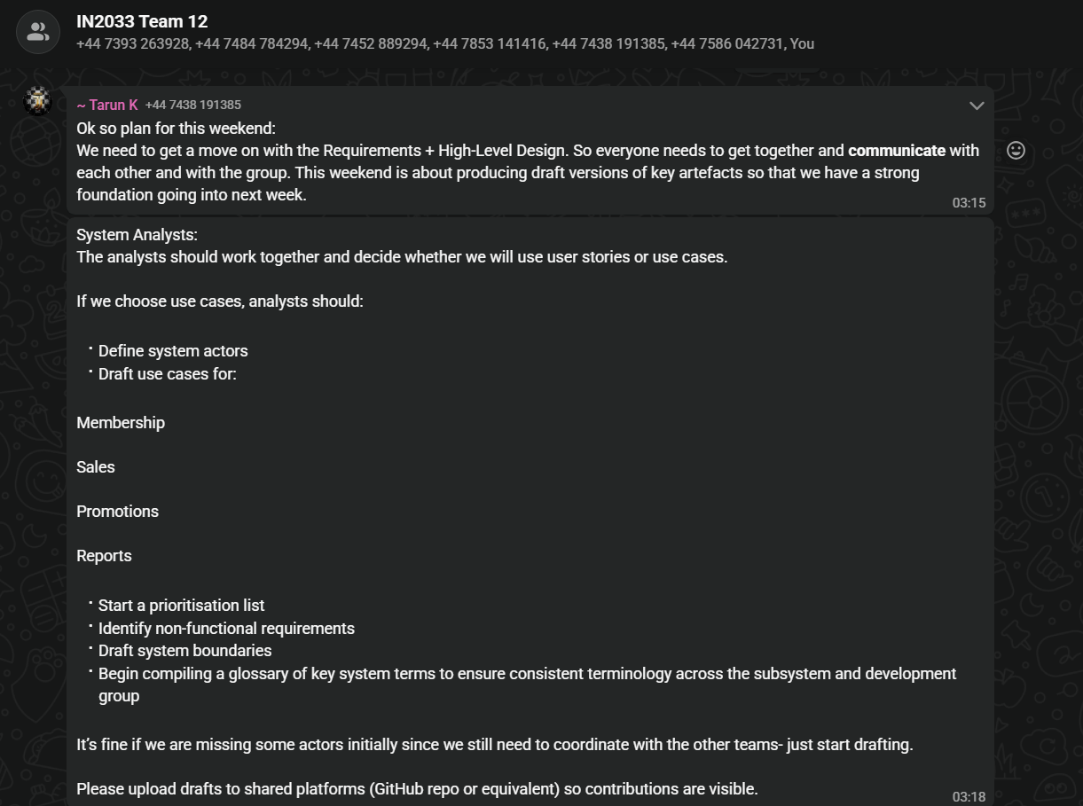
Testers
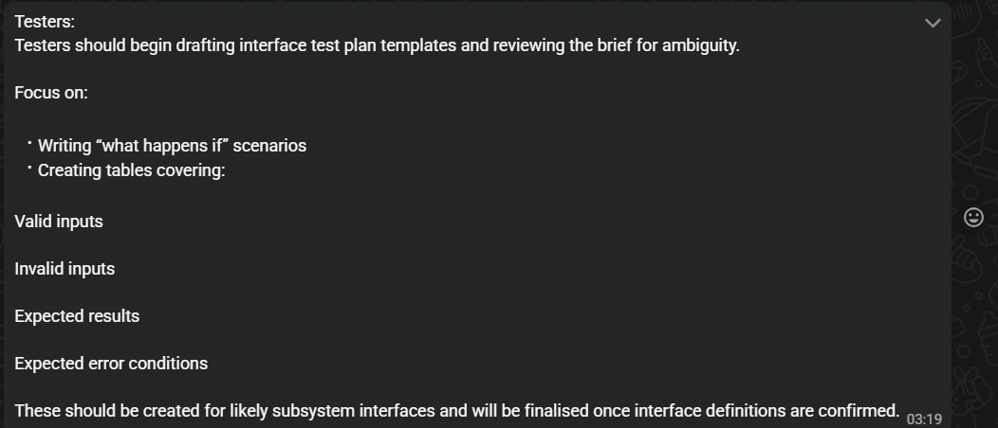

Designers
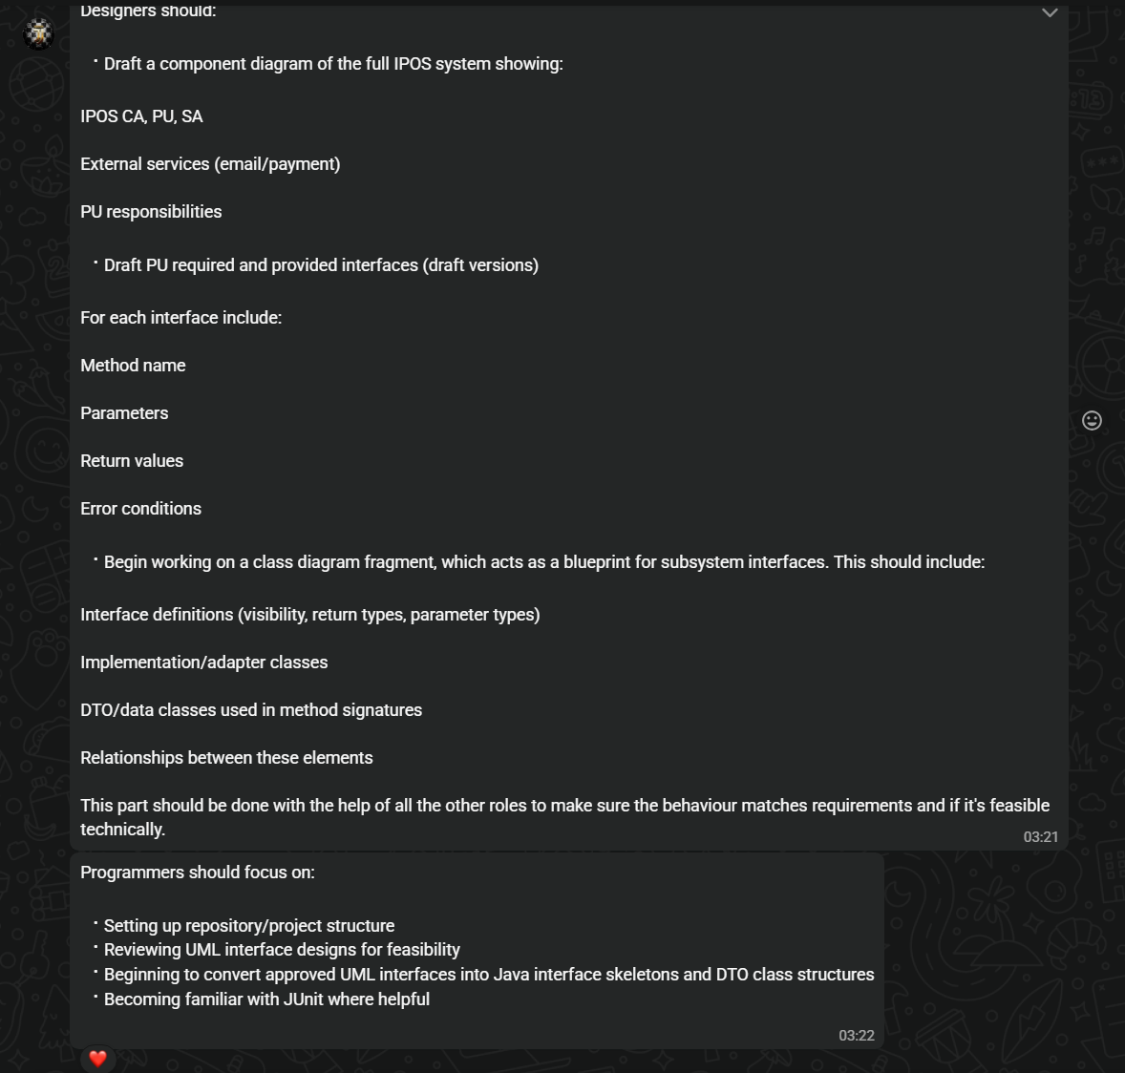

Conferring with Teams A and B
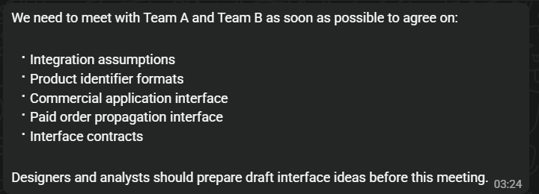

February 6th - 8th Task Completion

Designers

Testers

System Analysts

Programmers

